Name: Jagtap Shivraj Vaibhav
Roll no: EN24107060
Class: SY- AI&DS – A
Subject : Robotics and Automation (MDM)
______________________________________________________________________________________________

Experiment No:-2
Title:-
Study on selection of Sensors such as IR sensors, Proximity Sensor, UltrasonicSensor, White line sensor, Temperature Sensor, Touch sensor, Tilt Sensor ,Accelerometer, Gyroscopic Sensor etc. based on given application.
- A conveyor system must separate metallic objects from plastic components automatically.
- Which sensor will you select?
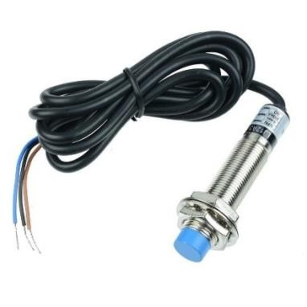

Fig 1

- Why is it suitable for this application?
1.Detects only metallic objects using electromagnetic induction.
2.Ignores plastic components automatically.
3.Fast response and reliable for conveyor automation.
4.No physical contact required.
2. A storage tank contains chemically reactive liquid. The level must be measured without physical
contact.
• Select the appropriate sensor
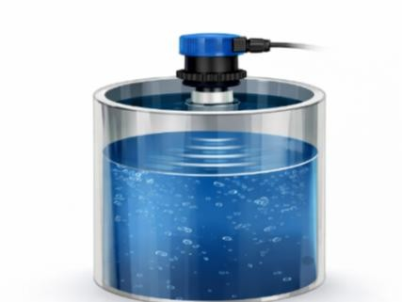

Fig 2

- Justify your choice based on safety and reliability.
1.Non-Contact Measurement :-
- The sensor is mounted at the top of the tank.
- Uses ultrasonic sound waves to measure liquid level.
- No direct contact with the chemically reactive liquid.
- High Safety :-
  - Prevents corrosion or chemical damage to sensor parts.
  - Suitable for hazardous, toxic, or reactive liquids.
  - No risk of contamination.
3.Reliable Operation :-
  - Works independently of liquid color or transparency.
  - Provides continuous level monitoring.
  - Minimal maintenance required.
- A robot must detect obstacles within a range of 20 cm to 2 meters.
  - Choose between IR and ultrasonic sensor.
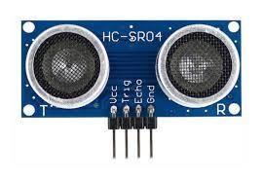

Fig 3
  - Justify your selection with technical reasoning.
Selected Sensor: Ultrasonic Sensor
  - Technical Justification:
1.Accurate in the 20 cm–2 m range.
2.Works on sound waves, not affected much by object color.
3.Better than IR for varying surface types and lighting conditions.
- A robot must follow a black line on a white floor in an industrial warehouse.
• Which sensor is suitable?
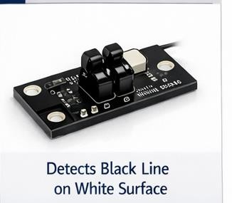

Fig 4
• Explain how surface contrast affects detection.
1.White surface reflects IR light → High signal.
2.Black line absorbs IR light → Low signal.
3.Sensor detects this contrast difference to follow the path.
5. A room automation system must continuously monitor temperature for HVAC control.
• Select suitable temperature sensor.
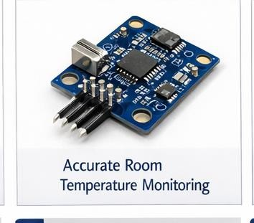
.

Fig 5

- Why would a thermocouple not be preferred for normal room conditions?
Selected Sensor: Digital Temperature Sensor (e.g., LM35 / DHT22)
- Why not Thermocouple?
1.Thermocouples are designed for very high temperatures.
2.Lower accuracy at room temperature.
3.Requires additional signal conditioning.
4.Costlier and unnecessary for normal HVAC range (20–40°C).
6. A quadcopter requires stable flight and tilt correction.
• Which sensors are necessary?
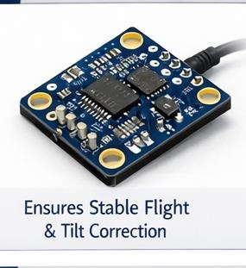

Fig 6
- Why is sensor fusion important?
Required Sensors:
- Accelerometer
- Gyroscope
- (Combined as IMU – Inertial Measurement Unit) Why Sensor Fusion?
- Accelerometer measures tilt (gravity reference).
- Gyroscope measures angular rotation.
- Fusion improves accuracy, reduces drift, ensures stable flight.
7. A rotating motor must be monitored for abnormal vibration to prevent failure.
• Which sensor is most appropriate?
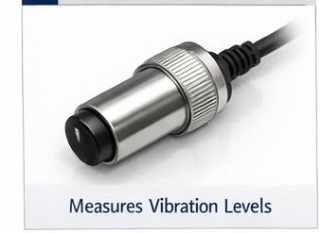

Fig 7
Selected Sensor: Vibration Sensor
• What parameter does it measure?
Measured Parameter:
1.Vibration amplitude
2.Acceleration (m/s²)
3.Frequency changes
Used for predictive maintenance and fault detection.
8. A commercial building requires automatic door opening when a person approaches.
• Select suitable sensor.
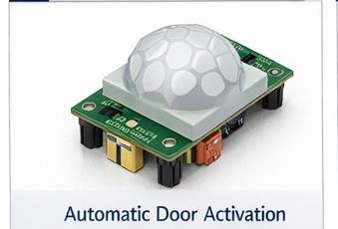

Fig 8
• Mention environmental factors affecting performance.
Selected Sensor: PIR Motion Sensor
Environmental Factors Affecting Performance:
1.Temperature variations
2.Direct sunlight
3.Air drafts
4.Presence of heat sources
Detects human body infrared radiation.
9. A mobile device must detect orientation changes (portrait/landscape).
• Which sensor is used?
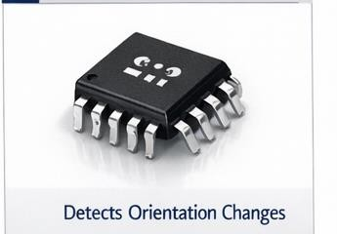

Fig 9
• Explain briefly how it detects motion. Selected Sensor: Accelerometer
How it detects motion:
1.Measures acceleration along X, Y, Z axes.
2.Detects gravity direction.
3Determines portrait or landscape orientation.
10. A car requires rear obstacle distance measurement up to 3 meters.
• Which sensor will you choose?
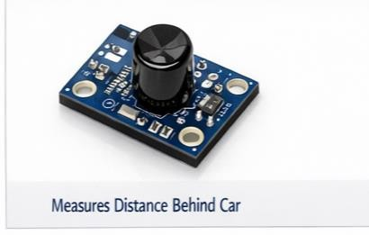

Fig 10
• Mention limitations under rain or extreme weather. Selected Sensor: Ultrasonic Parking Sensor
Limitations in Rain/Extreme Weather:
1.Heavy rain may scatter sound waves.
2.Mud/dirt on sensor reduces accuracy.
3.Extreme temperature affects sound speed slightly.

Conclusion:
- This experiment helped in understanding the selection of appropriate sensors based on different real-world applications in robotics and automation. Various sensors such as inductive proximity sensors, ultrasonic sensors, IR sensors, temperature sensors, accelerometers, gyroscopes, and PIR sensors were studied in detail.
- It was observed that each sensor works on a specific principle and is best suited for particular conditions—for example, inductive sensors for metallic detection, ultrasonic sensors for non-contact distance measurement, and IR sensors for line following. The importance of factors like accuracy, safety, environmental conditions, and cost was also highlighted while selecting sensors.
- Additionally, the concept of sensor fusion, especially in applications like quadcopters, showed how combining multiple sensors improves performance and reliability.
- Overall, the experiment enhanced knowledge of sensor characteristics, working principles, and practical applications, which is essential for designing efficient and intelligent automation systems.

